**TOPICS**

* General introduction
* Processes and threads (Abstraction of CPU)

------------------HALF OF THE SEMESTER------------------

* Memory management (Abstraction of MEMORY)
* File systems (Abstraction of I/O DEVICES)
* Input/Output (Abstraction of I/O DEVICES)

------------------BELOW ONES ARE EXTRA------------------

* Virtualization and cloud
* Security
* Deadlocks

Why Study OS?

Windows 10 is 50 million lines of codes.

When simple “hello world” program is compiled, it touches 1 million lines of OS and library code.

Studying OS is learning how to deal with complexity:

* Abstractions (+ interfaces)
* Modularity (+ structure)
* Iteration (+ learning from experience)

OS in 2 ways:

* OS is software that abstracts the computer hardware through interfaces.
* Hides the messy details of the underlying hardware (SATA drive (Harddisk drive standard – 400 pages!)
* Presents users with a resource abstraction that is easy to use
* Extends or virtualizes the underlying machine
  + Suppose I have single CPU in my system, only 1 program can run at the same time. I want to run 3 things.
  + It is the task of the OS to virtualize the CPU so that, as an user, I see 3 CPUs and 3 memory resources. Each program thinks that they have their own CPU and memory.
* Manages the resources
* Processors, memory, timers, disks, mice, network interfaces, printers, displays, …
  + Generating the clock signals is very important bc when the program runs, it doesn’t know how much time passes. We need to produce the time signals and from time to time we need to interrupt the programs so that they stop running and OS takes over. That’s why timers are very important. We need to time the program running durations to be fair between the programs bc we don’t want any program to take the CPU away and use it indefinitely.
* Allows multiple users and programs to share the resources and coordinates the sharing

OS as Hardware Abstraction

A modern computer consists of:

* One or more processors
* Main memory
* Disks
* Printers
* Various I/O devices

Managing all these components requires a layer of software – the OS

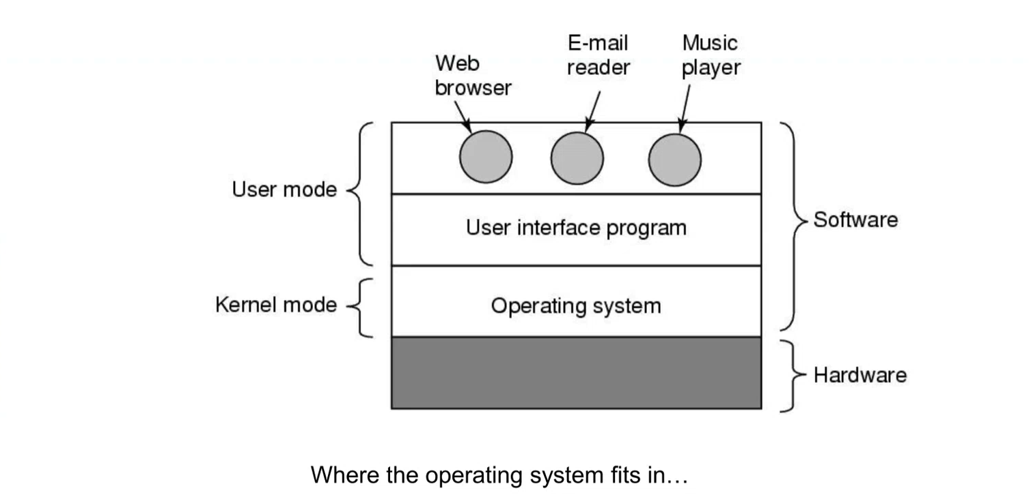



fopen(“hello.txt”);

* fopen is a function in the user interface program
* When it is translated to I/O device language, it gets very complicated
* In order to be able to write sth to a file in a SATA drive or read a file from a SATA drive, somebody has to implement all 400 hundred pages of standard. This is only for the harddisk.
* There are many details about the solid state drives, mice, keyboard, network adapter, etc.
* Managin all those components, interacting with them, reading from them, writing to them and while we are doing these, being protected, efficient are the concerns about the things that OS does.

OS as Resource Manager

Allow multiple programs to run at the same time

Manage and protect memory, I/O devices, and other resources

Includes multiplexing (sharing) resources in 2 different ways:

1. In time
2. In space
   1. Of course, this raises issues of fairness, protection (when you switch from one process to another process the second process shouldn’t be able to access to first process’s memory), and so on, and it is up to the OS to solve them

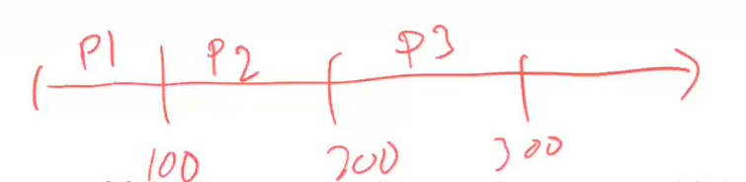

This is in-time sharing. I use my CPU 100 ms for process 1, etc.

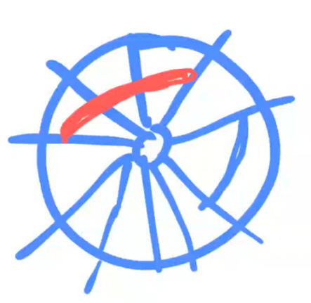Lets say this is a mechanical disk. It is divided into sectors and tracks.

I might say that red part belongs to user 1, blue part belongs to user 2. This is space sharing (multiplexing).

Processes think they have the whole computer.

OS is also using the resources. It has to be efficient. Efficient olmaya çalışmak protection ve fairness tan feraget etmeyi gerektirebilir.

Operating System vs Kernel

Wide view

* Windows, Linux, Max OSX (not very well documented) are operating systems
* Includes system programs, system libraries, servers, shells, GUI, etc.

Narrow definition:

* OS often equated with the kernel
* Kernel is part of the OS that runs with special privileges
* The Linux kernel; the Windows executive – the special piece of software that runs with special privileges and actually controls the machine
* CPU has several modes, one of the modes is privilege mode. If your software runs on the CPU in the privilege mode, it can do whatever it wants. It can access any part of the memory, it can setup the DMA devices, it can change your page tables, it can disable interrupts and enable them and do whatever it wants.
* If you are on the kernel mode (or privilege mode) you can do whatever you want. Only the OS (some special part of it) runs in the kernel mode. User programs don’t run in the kernel mode. That is too dangerous.

In this class, usually mean the narrow definition

* OS is special piece of software that runs in the kernel mode. We are talking about “some part” of it.

For most people, though, the wide view is what counts

* They took OS as a whole (all 50 million lines of code). Including the backup programs, email readers, web browser…
* When you install Windows, it comes with a web browser, email reader, painting program, etc.
* We say that they don’t run in the kernel mode. They are regular user programs. They are part of the wide view of the OS.

History of Operating Systems

Generations:

|  |  |
| --- | --- |
| **(1945-55)** | Vacuum Tubes: Programming languages were unknown, operating systems were unheard of    Each vacuum tube is single bit of information. It is very large and consumes so much power. They break all the time.  Programming a computer is simply meant somebody playing with the bits one by one.  Very early operating systems:   * the first computers had no os * the concept isn’t very meaningful on a plugboard or electromechanical device   Dedicated time only, manually managed    You dial in your program bit by bit by hand. Woman at right is modifying the memory locations of the computer.  Computers were not powerful enough to handle running more than one program at the same time.  The 1946 ENIAC computer used 17468 vacuum tubes and consumed 150 kW of power (today it is 0.7 kW).  Computer ENIAC is used in military.  There were no OS in the first computers because machines are not able to run an OS. They are powerful enough to run complicated computations but not both of them at the same time bc OS has to be on my memory all the time along with my programs. Those computers didn’t have enough memory to hold more than one program at the same time. If they had it, they didn’t have CPU to do all those things at the same time. |
| **(1955-65)** | Transistors and Batch Systems: Mainframes, Primitive OS, FORTRAN, batch systems  There are transistors but no OS.  2nd Generation: The Early Punchcard Era  Punchcards – first used for data processing in the 1880s – made preparing programs easier  But card readers were too slow; they tied up the (very expensive) CPU  Printers had similar problems  Solution: use slower, cheaper computer to copy input/output to/from mag tape    You put a hole at the appropriate column.    Structure of a typical Fortran Monitor System job.  You feed these card sets to a card reader.  When computer 7094 sees the $FORTRAN input, it immediately loads the fortran compiler.  There is a computer (IBM 1401) that is relatively cheap (200 000 dollars).    Task of this computer is to read cards and put all the information to tape drive.  Card reader is very slow compared to computer.  Tape drive is magnetic tape. It is much faster than the card reader.  Then they take tape drive, put it to a very expensive computer, IBM 7094 (the 10 million dollar computer, faster).    Since reading the data from the tape is much faster (comparing to human entering bit by bit), this computer reads the data and the computer program. System tape holds the user libraries and compilers. When this program runs on this computer, it reads the data, program and system libraries. Then it calculates the results and it puts everything back to another tape. Another person takes this output tape and puts it in another computer, IBM 1401 again.  Data to be computed is in the input tape. Input tape comes from the card readers. All my data and instructions are read through the tape drive, to the input tape.    Task of this computer is printing the results out.  In short, an early batch system:   * operator carries input tape to 7094 * 7094 does computing * operator carries output tape to 1401 * 1401 prints out   That’s how we started using transistors.  This is a batch system because in system tape, there are many tasks (batch of tasks). When computer 7094 starts running one of the tests, It continues to run it as soon as it is done with them. Then it needs next one, next one…  This computer (7094) is not wasting any time waiting for the user to input data or card reader to be read. It is reading the data and the programs as fast as possible from the input tape.  We need to keep 7094 computer busy because it is expensive. Reading the input tape and writing to output tape are easy, but doing the computation takes time so 7094 is busy most of the time.  While the user is entering the programs bit by bit in ENIAC, I am wasting time, I am not running any programs. Punchcard input method and tapedrive system, things became cheaper in terms of cost per user.  It may take a day to get your results in batch system. But you can use this system by 100 people.  For ENIAC, 4-5 people might be using it but you get your results instantly.  After punchcards, they invented terminals to enter your code and data.    Computers Helping Themselves   * The realization that computers could help themselves was fairly early * The first assembler was written by 1952   Assembler takes assembly program and produces the machine code   * Operating systems descend from this observation: that computers were useful for non-numeric and non-data processing work |
| **(1965-80)** | ICs and Multiprogramming: multiprogramming, spooling, timesharing, MULTICS (not in use today)  Something recognizably an OS  Memory protection; multiprogramming  Programs stored on disk  Multiprogramming, spooling, timesharing, MULTICS   * MULTICS 🡪 UNIX 🡪 LINUX 🡪 ANDROID * Commercially, MULTICS was not a successful OS but introduced lots of idea * Most of the time MULTICS is responsible for commands like ls, terminal shape etc.   With spooling, the 1401s were no longer needed, and much carrying of tapes disappeared  Multiprogramming 🡪 having more than 1 program in my memory   * Run several programs at once * Protect each one’s memory against the others * When one program needs to do I/O, let another program use the CPU * As necessary, pre-empt a CPU-bound program to let another run   When the timer interrupt happens, OS takes over the CPU and I let another  program use the CPU. Even that program is not blocked, even it still needs the CPU.   * Use OS “daemons” for spooling – Simultaneous Peripheral Output OnLine * That is what makes the I/O/ computers go away T   There is a printer spooler, input spooler, etc.  It is a special process belongs to OS and it just waits there empth without doing  anything. Whenever I need to print sth to the printer, the OS tells me to print it.  From time to time I am going to be blocked because print is very slow.  daemons 🡪 Waiting sth to happen. When it happens, they will handle it.  Waiting for OS to ask them to do sth.  Each information in task manager is kept by the OS. It keeps this statistics so that it can be fair when it assign the CPU, memory. You don’t want a program to use 95% of the CPU and memory.  When you close Chrome for example, memory usage doesn’t change much. When I say load this Chrome app to memory, it doesn’t keep everything on the memory. It keeps some of it on the disk. Whenever it is needed, it is swapped back and forth.    These 4 programs have to use CPU in time sharing way.  OS knows that there are 3 more programs in the memory and they have to be run.  Job 1 doesn’t know there are more programs in the memory. It runs in the user mode. How do I switch from Job 1 to Job 2 or Job 3 or OS? We have some kind of hardware help, we have timer interrupts. When timer interrupt happens CPU stops whatever it does and OS takes the control again. Maybe after 20 ms, interrupt will happen and that interrupt will be handled by the OS. Now OS is running. It handles this interrupt and say I am going to let somebody to take the CPU. It could be J1, J2, or J3. I don’t know. Assume it made the decision J3. Then same thing happens, OS takes over. Choose a job.  Timeline:    This is what multiprogramming is.  Switching from one job to another job, from OS to another one is expensive because it causes cache miss. When you switch, many cache entries are invalidated.  Trade off: You don’t want to switch to often. You don’t want to switch too late. You have to find a balance. That’s the task for choosing your parameters for your OS.  Are interrupt and timer values pre-assigned? ------> It is done by the OS, values are very critical     * This is a simplified architecture of our computer system. All components are connected to ssame system bus. * There is another device called system clock or timer. * Usually, accessing the time can be done only in privileged mode. So only OS can program timer. OS says that “you are gonna produce an interrupt at every 20 ms.” * If a program behaves badly, OS can kill that process. Deletes it from the memory.   OS cant detect if program behaved badly in the past and doesn’t block it to load  to memory from the disk next time but program will understand it is closed  inappropriately.   * Task of the timer is to cause interrupts and give control to the OS. * When the timer interrupts happen, CPU stops whatever it is doing and OS takes over. * Without timer interrupt, maybe that job is gonna take the CPU forever. * Other than the OS, nobody knows that there is a timer.   They have enough memory to keep many programs at the same time and CPUs are powerful enough so they invented multiprogramming.  If J1 started running, it cannot use its assigned 20 ms most of the time because J1 will need some data from I/O device for example. Lets say J1 needs data from the disk. OS reads the disk. J1 will ask to OS to read the disk data and bring it to me but reading the disk data is so slow. Million times slower than reading data from memory. OS will not wait until the disk data is ready. While the disk is retrieving the data, OS is gonna let J2 to take the CPU. Maybe J2 is gonna print sth to terminal. That’s very slow process too. So J2 is gonna ask to OS to print sth. Neither J1 nor J2 has direct access to printer or screen. They will ask OS to do those things. OS always comes in to provide those kind of services. Remember main task of the OS: Abstract away the details of disk or terminals or that kind of stuffs. Printing takes time so OS is gonna check if the data from the disk is available. If it is available, it is gonna switch back to J1.  In this scenario I don’t need the timer interrupts most of the time. Because before timer interrupts, J1 or J2 stops themselves already. They will ask to OS to do sth for them.  Efficiency   * Mainframes still cost millions of dollars * The CPU was idle while I/O was going on, multiprogramming solves this now CPU is never idle * Save the cost of I/O computers (1401 computers)   I can connect my card reader and printer to 7094  There is a card reading, printing programs and other programs running on 7094 computer  I am not wasting even a single cycle of expensive computer.  Important concepts: memory protection (We need MNU), virtual memory (We need MNU), interrupts (We need interrupt generation hardware and interrupt handling hardware) – OS knows all about the hardware in parantheses, only OS is authorized to use them.   * J1 should never be able to access the memory of J2 or J3. When OS switches from J1 to J2, it sets up hardware MEMORY MANAGEMENT UNIT (MNU) in a way that J1 can only access to its own memory, not anywhere else. * Today, OSs are very robuts. In the past they crash sometimes (modifying memory locations of other jobs) because they don’t have hardware help this much. * === * Each job running on my computer think that they have their own memory and that memory address starts at address number 0 to some large number. Remember C, address number 0 is null. You are not able to write anything to that address because that’s a special address. At the top you have stack, your heap growing up etc. Each C program thinks that it has its own contiguous memory allocation. It is given by the OS. I am free to use this all the time. What’s actually happening is this: At the bottom I have OS pages, and then I have jobs’ pages:     I have divided my J1 memory into 2 pieces.  In the physical memory, they are stored in non-contiguous way as you see left.  In logical memory, that program thinks that I have my own memory.  Remember the OS definition, it extends or virtualizes the underlying hardware. That’s what we mean here. It virtualizes the memory in a way that each program would think that they have their own contiguous memory.   * === * Stop whatever you are doing, OS takes over the CPU and handles the interrupt. If disk drive says that your data is ready, this is also an interrupt. Interrupt could be a simple keystroke on keyboard or **timer** interrupt or disk interrupt or network interrupt…   Hardware had improved to the point that an OS was feasible:   * Enough RAM (“core”) to hold it * Disks became the norm * Fast enough CPUs   Beginnings of remote access |
| **(1980-Present)** | Personal Computers: LSI (Large Scale Integration) circuit, DOS, Windows, OS X, FreeBSD, Linux   * LSI: Transistors are getting smaller and smaller. 1401 computers are cheap enough ($5000) to be sold to small businesses and home businesses. Now people try to run stuff that never run before like games etc. * 1980s IBM designed the IBM PC * Bill Gates paid $75000 (investment) for DOS, made it MS-DOS   All he had was basic language interpreter. He bought another OS from somebody  and sold it to IBM.  IBM went to guy that sold DOS to Bill Gates. Guy said that I am not going to give  you my OS but Bill Gates did.   * In 1960s, Engelbart invented the Graphical User Interface, complete with windows, icons, menus, and mouse. * Apple adopted BSD Unix for MacOS in 1999 * Windows NT was similar to VAX VMS 2000 * Efficiency is not concerned about with these computers. You can see 90% of your CPU is idle in task manager. I didn’t buy computer to use it very efficiently. * Interactivity and responsiveness are the issue (central idea). I want sth to happen when I click on a button. |
| **(1990-Present)** | Mobile Computers  mid 1990s when Nokia released the N9000, which literally combined two, mostly separate devices: a phone and a PDA (Personal Digital Assistant).  In 1997, Ericsson coined the term smartphone for its GS88 “Penelope.”  Other operating systems like RIM’s Blackberry OS (introduced for smartphones in 2002)  Apple’s iOS (released for the first iPhone in 2007)  Android, a Linux-based OS released by Google in 2008  Top of interactivity and responsiveness, security and battery management are the issue  You don’t care much about your desktop OS power usage but it is important for the smartphone or laptop computer  These computers shouldn’t run your CPU 100% of the time because of battery usage. That’s the opposite of what you do in 1960s. |

When the first personal computers started appearing (1980s), they had to solve the exact same problems that the initial computers were solving (1955-65).

For initial computers, OS was very slow because computers were not powerful enough to run them.

When we invented personal computers, they were not powerful enough to run a complicated OS. So I am using primitive operating systems.

When we had first mobile computers, our cell phone computers were not very powerful. So interactivity suffered some security issues and etc.

ALL IN ALL, when you receive a new generation of computer or OS, we have to solve the same problem over and over again.

In 1990s, when writing programs for personal computers, we used to have a system crash maybe 2 or 3 times a day because we didn’t have the protection hardware. Nowadays they are having the same problem for the embedded systems. They are very cheap (1$ whole computer) computers. Maybe 50 cent CPU but very unpowerful. You cannot have protection hardware or large powerful sophisticated OS on it.

Ivan Sutherland is the inventor of GUI in 1960s.

Lightpen is connected to CRT operation. Do this kind of stuff at your own computer took use some time. Do in any other computer, we need OS help. That’s why OS kept changing and they came to position that desktop OS and smartphone OS are very different.

Moore Law (1970s): the number of transistors in a dense integrated circuit (IC) doubles about every two years. He said that, for 1000 $ you can buy 2 times as powerful computer every 2 years. This trend continued from 1970 to 2010s.

Moore was one of the founders of the Intel Corporation.

Intel thought that nobody buy a personal computer so they build CPUs. They thought that CPUs are gonna be used by other devices, not by the computers.

Altair 8800 was the first personal computer. It didn’t have any OS because it is not powerful enough to hold any OS. You cannot run OS and other programs at the same time. You program this computer through switches on it. You specify the address with switches. With another set of switches, you specify the data to put in to that address. Then you tell to CPU to run later. Altair 8800 was using Intel CPU. Inventor of this computer became a medical doctor (Henry Edward Roberts) after. He didn’t make any money out of it.

When Bill Gates saw Altair 8800, he decided to write the basic interpreter for this computer. He sold this interpreter to Edward. This interpreter became the first interpreter running on a personal computer.

You buy Altair 8800 in pieces and assemble it yourself. Later they added peripherals to it.

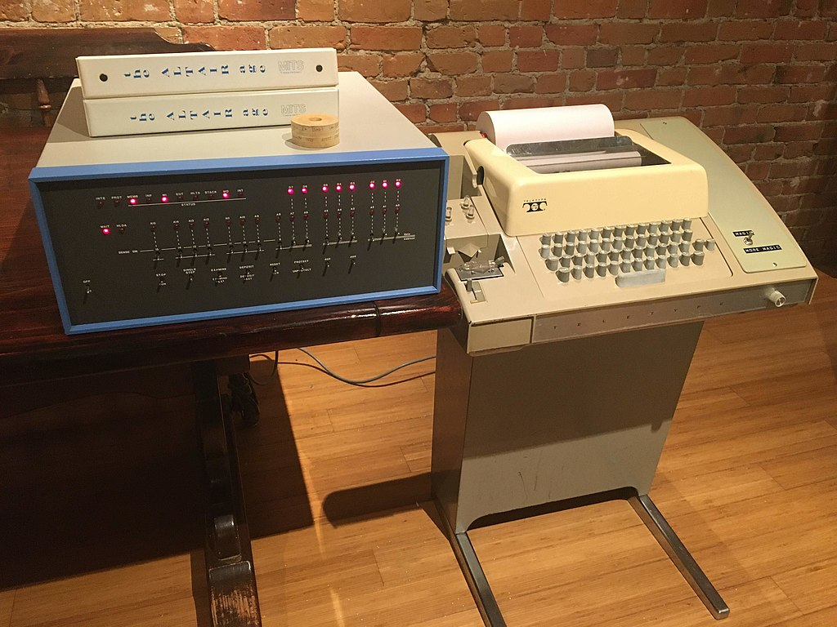

Right one is for printer.

You input your data using some tapes or switches.

**COMPUTER HARDWARE REVIEW**

OS needs to know the hardware that is running on. It is designed hardware specific.

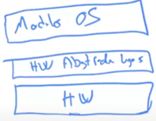You have hardware, usually on top of it you have hardware abstraction layer. This is how they designed the OS. On top of it you have moduler (portable) OS. This modular OS would think that hardware underneath is the same. It doesn’t care if the hardware is Motorola Hardware or Inter Hardware or ARM Hardware. Some part of the OS is portable. I can port it anywhere I want. But Abstraction layer has to be specific for that hardware. This is the design of the OS. That’s why you see that the same OS that can work on ARM processors or Intel processors.

They made it even more portable by doing virtualization (Virtual Machines).

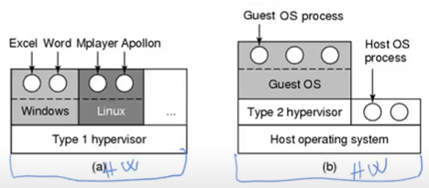



On top of hardware, you are running, lets say, Windows OS. On the Windows OS, you have your Teams program, Word program, etc.

I can run hypervisor to make it look like guest OS would think that it is running on a hardware platform like Host OS. So type 2 hypervisor shows itself as a hardware platform so you are running Gues OS (Lets say Linux) on it. Guest OS can be Macintosh OS or MARS OS or some old Windows OS, doesn’t matter.

Guest OS doesn’t know that it is running on some kind of software, not hardware. This is called virtualization and it is very popular. It is extension of OS idea. OS abstracts away the details of the hardware. This hypervisor abstracts away the details of how the things are done. Doesn’t matter if it is running those services through the software or hardware, guest OS would think that it is running on real hardware.

Guest OS, hypervisor and Host OS are all software, they have to run on hardware physically. That’s why it gets more expensive, that’s why virtual boxes is gonna run a little bit slow.

When guest OS is trying to access to mouse, it says that read the mouse register for me. It thinks that it is accessing the controller of the mouse device but actually it is saying sth to type 2 hypervisor. If hypervisor is not capable of translating that request to host OS, then guest OS cannot use the mouse.

Only host OS is running in kernel mode. How could guest OS modify the memory management unit register if it is not running in kernel mode? MMU has to be modified so that Guest OS processes can run. When guest OS tries to access to MMU, it will cause an interrupt because regular program tries to access to MMU. Host OS handles this interrupt. I ask to host OS. If you get such a request from the guest OS, then let it go through. Then host OS will behave specially when the request comes from the type 2 hypervisor. That’s why it is a little bit different to install virtual machine on your operating system than installing a regular program. Guest OS doesn’t have any privilege. Things are done by hypervisor.

If hypervisor behaves badly, host OS has control. It can terminate type 2 hypervisor. As a user you are installing hypervisor. It is kinda your responsibility to install it from trustworthy places. There are not many type 2 hypervisors. If someone makes malicious modifitcations to vmware for example, that becomes a problem.

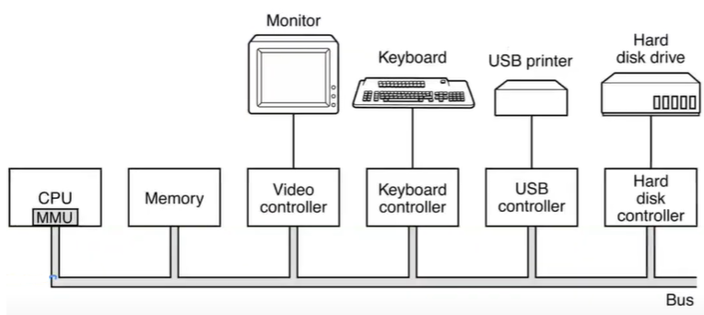

*Some of the components of a simple personal computer.*

Width of the bus is dependent on the CPU and the memory capabilities. For the early PCs, it is 8-bit or 16-bit. That means you can read 16 bits from the memory. Nowadays it is 64-bit.

MMU (Memory Management Unit) sits inside the CPU. It is used for virtualizing the memory. Any program running on the CPU would think that they have their own CPU.

CPU communicates with other controllers too only in kernel mode.

BUS is controlled by the bus controlling hardware.

OS has the privilege to control bus.

Ordinary programs are not allowed to control video controller, keyboard controller, etc. Only the OS has privilege to communicate with them.

As an end user program, all I can say is read some characters from the keyboard. I don’t know how it is done. OS and controller do it.

Keyboard controller has special memory locations in it. When data is ready, keyboard controller makes corresponding register in it true. A memory location gives you the key pressed by the user on the keyboard. Lets say there is a number 27 in location and it corresponds to one of the keys. Another location is for the caps lock. Another one is for the scroll lock. Communication with keyboard is not difficult. All you do is if there is number 27, that means someone pressed the key number 27 whatever it is. If caps lock register is 1, that means caps lock is on. For some CPUs there are some special I/O instructions that can read special locations. This is how you communicate with the keyboard controller from the CPU.

Video controller is another hardware component. Lets say you have 80 columns and 40 lines. You want to put letter A at one cell. In my video controller, I have same memory arrangement (80 bytes x 40 bytes). If I put corresponding cell number 65, it will print letter A in that location.

USB controller is more complicated because it has to communicate with many different types of devices.

Hard disk controller is also complicated. Sometimes these controllers are multi-CPU computers. Sometimes they have to use computers as the controllers.

**PROCESSOR**

Brain of the computer.

Fetch, decode, execute, and repeat

CPUs have registers

* Single clock cycle to access registers.
* If you can, write your programs to use only registers. It would be faster.

Program counter

* Special register
* Like pointer to some location in memory, it says that I am executing this position

Stack pointer

* Another register
* Stack is there to keep our data about local variables, function return position, etc.

Program Status Word (PSW): condition bits, **kernel mode**, CPU priority etc.

* kernel mode tells to CPU that if it is running in kernel mode
* If CPU in kernel mode it can access any memory location, program the I/O registers, program the interrupt controller, program the MMU, etc.
* If CPU executes an instruction in user mode that tries to access the MMU registers, then CPU is gonna create an interrupt. Stop what you are doing and go to the interrupt handling function. This function belongs to OS. Now I am in kernel mode and handling the interrupt.

To obtaing services from the OS, a user program must make a **system call (special instruction)**, which traps into the kernel and invokes the OS.

* Program says that “I need a help from OS. I am making a system call. Please get me a character from the keyboard.”. So I make a system call. As soon as I make a system call, I am in kernel mode and OS is executing now. If it is sth OS can do, it will do it. Otherwise OS says “You don’t have any permission to ask for this kind of system call. I will terminate you or I will let you know that I am not gonna do anything.”
* Some early CPUs don’t have system call instructions

CPU Pipelining

For superscalar CPUs, multiple execution units are present, for example, one for integer arithmetic, one for floating-point arithmetic, and one for Boolean operations

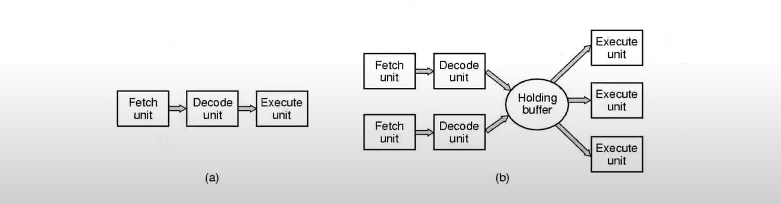

b:

* 2 fetch,
* 2 decode,
* 3 execution at the same time.
  + 7 different instructions are being handled at the same time for this superscalar CPU

Compiler has to be written in a way that it knows about the CPU Pipeline etc.

When it comes to handling the interrupts, we have to know about these pipelining stuffs.

Multithreading / Multicores

Moore’s law: 2 times more transistors every 18 months

Single processor can process more than one thread efficiently (multithreading)

Multicores: real multiple CPUs on the same chip

* With 4 cores, I can run 4 independent instructions at the same time in physical terms.

GPUs are extreme examples of multicores (thousands of cores)

* Used for processing graphical stuff like each pixel I have to make some calculation but I am calculating the same thing over and over again for different data. That’s why it is very efficient to parallelize them.
* Very primitive CPUs but thousands of them (thousands of cores). Convenient for screen updates and computer graphics.
* People started using GPUs for machine learning applications which is the same idea of doing the same calculation with different data millions of times. So GPUs are making things faster in that case.

Multithreaded and Multicore Chips

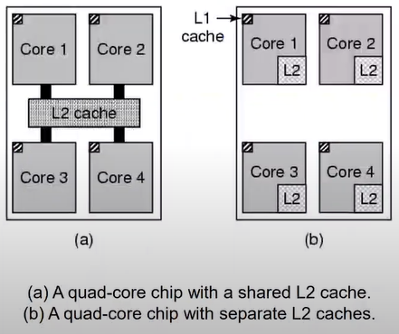

In multiCPU architecture, you have more than 1 CPU connected to the system bus.

Multicore cores communicate much faster because they are in the same CPU, they don’t use the bus.

**MEMORY**

Memory should be fast, large, and cheap

Not all possible with the current technology

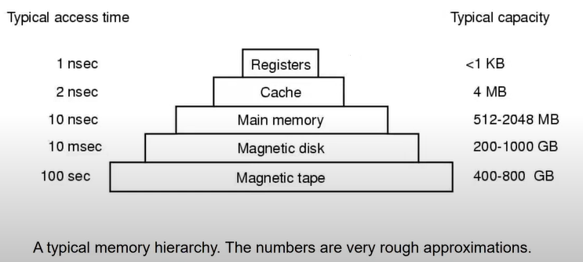

Registers are as fast as the CPU can handle. For a 64-bit computer, there are 64 registers available. We don’t we increase number of registers because it makes CPU a lot complicated. Paths of register access routes grow exponentially. Instead of 64, I put 128 registers; then I have to multiply the number of transistors by themselves for certain location of the CPU.

Magnetic disk is 10 miliseconds. Million times slower than main memory.

Magnatic tape is not larger than magnetic disk but they are cheaper.

When you go down things get cheaper, slower, larger.

Context switch: When you switch from one process to another process including one process to OS, it makes a context switch. When you do the context switch, CPU starts executing a different code. When you start executing different code, that means your cache will be invalidated. When it is invalidated, that means all the rest of the stuff will come from the main memory that’s 10 times slower.

Why are we invalidating the cache? Keep the cache as it is. Maybe we are gonna come back and use it.

* If I switch one process to another process and if I have leftover data from my other process, then new process can read other process’s data
* That creates some security problems.
  + Especially on servers. Lets say I am running my program on Amazon server, I don’t know what kind of other program is running on the same server but it switches back and forth. I can know what other people are running and their data if cache is not invalidated.

Without context switch, there is no talk of multiprogramming (keeping many programs in memory).

Write your context switch routine or task scheduling in a way that it is not much frequent but it shouldn’t be very infrequent either. Keep the balance. You should know access time, capacity knowledges to keep the balance.

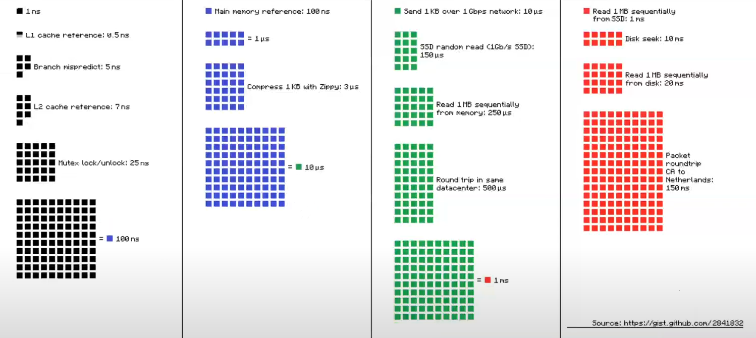Latency Numbers Every Programmer Should Know

Branch mispredict is about pipeline flush. If you know what your next instruction is, you can immediately start fetching it. Doesn’t matter where it is in the main memory. If you don’t know where it is, then you cannot fetch it.

Mutex lock/unlock is about synchronization.

SSD (solid state drive) means that it’s not a mechanical drive. Everything is kept electronically on transistors.

* If you read sth randomly (1 byte of data) from SSD, it’s gonna take 150 microseconds.
* If you read sth 1 MB of data sequentially from main memory is gonna take 250 microseconds.
* ---
* Even though both main memory and SSD use similar (not mechanical) technology, reading main memory is much faster. Why?
  + Main memory is connected to CPU using the much faster bus.

Red is disk that is mechanical.

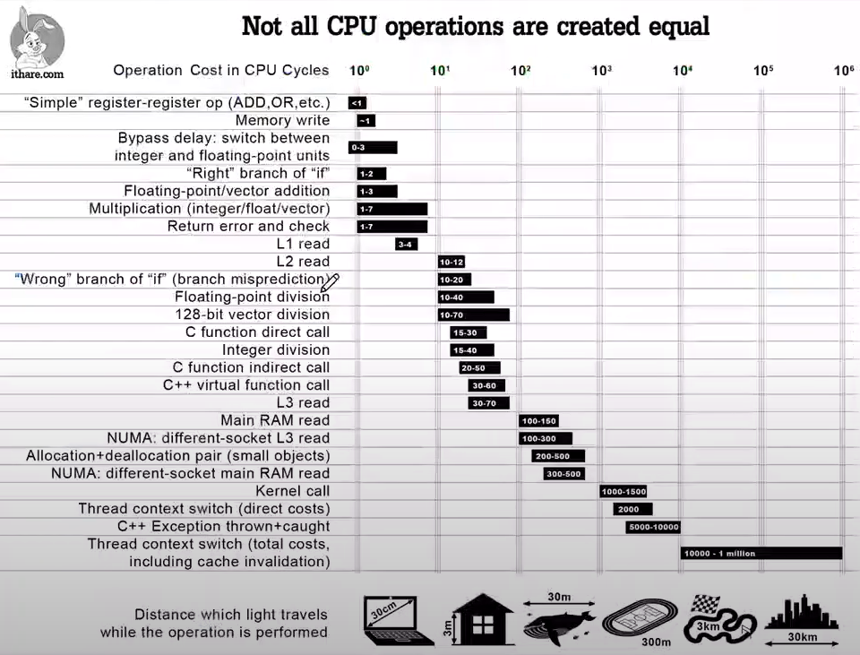

We assume all instructions are in the cache here.

Registers and Cache

(registers) 32x32 bits for 32 bit systems, 64x64 bits for 64 bit systems

* large the bit size, word size for a processor; the number of registers grow accordingly

No delay accessing them

L1 cache 16 KB

L2 cache a few megabytes

Questions when dealing with cache:

* When to put a new item into the cache
* Which cache line to put the new item in
* Which item to remove from the cache when a slot is needed
* Where to put a newly evicted item in the larger memory

**DISKS**

They are larger, cheaper and slower than the main memory

Slow because they are mechanical

Load OS and applications from disk

Manage disk space allocation

Store and retrieve files by name

Provide some protection for files

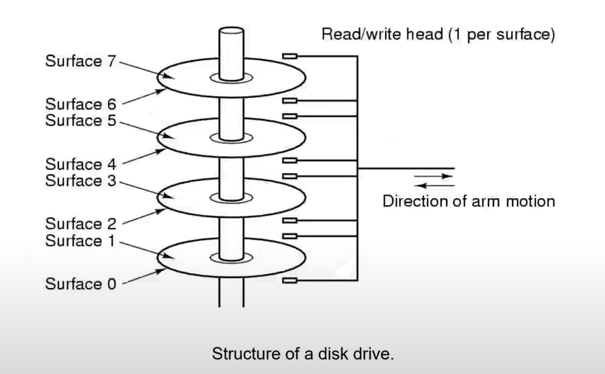

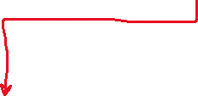

shaft platters

platters rotate 10 000 times per minute etc.

**I/O DEVICES**

I/O devices: controller (chip/s) and the device

The devices are very complicated, controller handles this complexity

Device driver: middle layer software for the device controller by the manufactures

All I/O devices are connected to system bus using controllers (electronic devices – hardware)

Each controller comes with its own software to act as a middle layer interfacing software between controller and OS

Part of the OS that programs these controllers are drivers. Drivers are pieces of software that knows how the controllers work. Without the driver, OS wouldn’t know how to communicate with the controller of that device.

Driver for sth come with the manufacturer of that device. I put that driver into my OS and it becomes part of my OS. If driver crashes, it crashes my whole OS. If driver is malicious, it can harm you like installing harmful hypervisor. So don’t make those drivers part of the OS but then driver doesn’t have privilege to access the device register. We will talk about these problems later.

3 types of I/O methods:

* Busy waiting: CPU waits until the I/O is over, I don’t need OS help
* Interrupts: CPU asks the driver to get the data and process blocks. When the data is ready, an interrupt is generated and process starts again
* Direct Memory Access (DMA): The CPU sets up the DMA chip, telling it how many bytes to transfer, the device and memory addresses involved, and the direction, and lets it go.
  + DMA puts the data in memory and OS doesn’t know about it

CPU says I need a character, data from the keyboard. I asked driver to give me one character from the keyboard. I can do 2 things:

* I will wait CPU, until the data is ready. 🡪 BUSY WAITING
  + while(*data == NULL)

;

* + Address of my data is most probably in the keyboard controller. If it is 0, I will wait until that thing becomes non-zero.
  + You are wasting time here. You should switch to another process so this approach is not good.
  + If nobody needs the CPU, there are daemons that need some CPU time, for example backup system. Backup system has very low priority and it runs when the computer is idle. So it is better to switch.
  + In embedded system, there is only 1 process so busy waiting can be good there.
* With the help of hardware; CPU says that I need data from the controller, I will switch to another process and when data is ready I should know about it so how am I gonna know that? I am gonna wait for an interrupt. 🡪 INTERRUPTS
  + When data is ready, controller will raise an interrupt (interrupt controller) and CPU stops whatever it is doing and interrupt is handled.

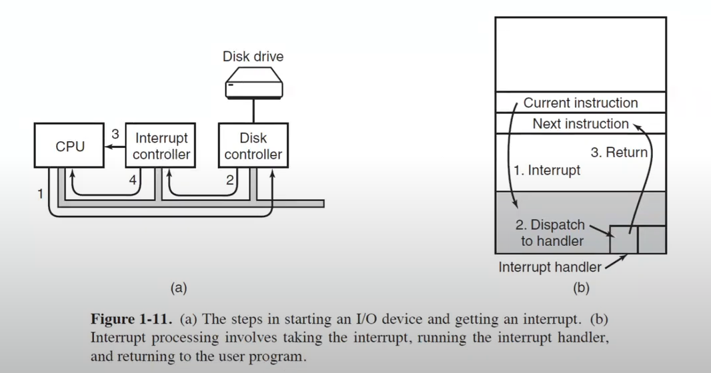

(a)

1. CPU is asking to disk controller: “Get me 1 MB of data from this location.”. Then CPU switches to another process.
2. When data is ready, disk controller tells to interrupt controller that data is ready.
3. Interrupt controller produces an interrupt on CPU. CPU stops whatever it is doing.
4. Interrupt will be handled accordingly.

Lets say 1 MB of data is ready at the disk controller. CPU needs to copy data from disk controller’s memory to memory of computer one by one (byte by byte or word by word). It takes some time. CPU is gonna do that. You don’t have to waste CPU’s time on this. Lets add another device to system bus which is DMA.

DMA is responsible for moving the data from controller’s memory whenever it needs to.

CPU sets up the DMA chip. It says that “I am waiting for 1 MB of data from this disk drive. Whenever it is ready, you will get an interrupt. Copy it to this location in the memory. After you are done, interrupt me.”. When data is ready, CPU will be interrupted. CPU doesn’t have to copy anything, its data is ready.

This chip makes computer more complicated (specially for embedded systems). So you may have a computer system without a DMA chip.

Interrupt controller also tells that you are gonna handle this type of interrupt by interrupt table. This table is like table of function pointers. Appropriate interrupt handler is got. Then interrupt is handled.

There is a separate line between the interrupt controller and CPU other than the system bus. Interrupt controller can use that line to interrupt the CPU anytime it needs to.

You cannot allow ordinary programs to program that interrupt controller. Only kernel mode CPU can program it.

Sometimes we may not want to use interrupts or DMA even though they are available. For some reasons I may prefer busy waiting:

* CONTEXT SWITCH is costly.
* Sometimes you know that after 100 loop iterations (while loop in busy waiting), your data will be ready.
* If I am gonna spend less than 10 000 cycles (min cost of context switch) in busy waiting, then I am not gonna set up any interrupts or any DMA chips.
* I can do this:
  + Take a few hundred cycles, loop iterations.
  + If data is not ready, switch to DMA – interrupt.

I will wait until special register in keyboard controller to be true, then I read the code of the pressed key.

How come my ordinary program in user mode can access the keyboard controller? I/O doesn’t have to be done by the user programs. I/O is done by the OS and OS can do busy waiting too.

Interrupts vs traps: System Calls

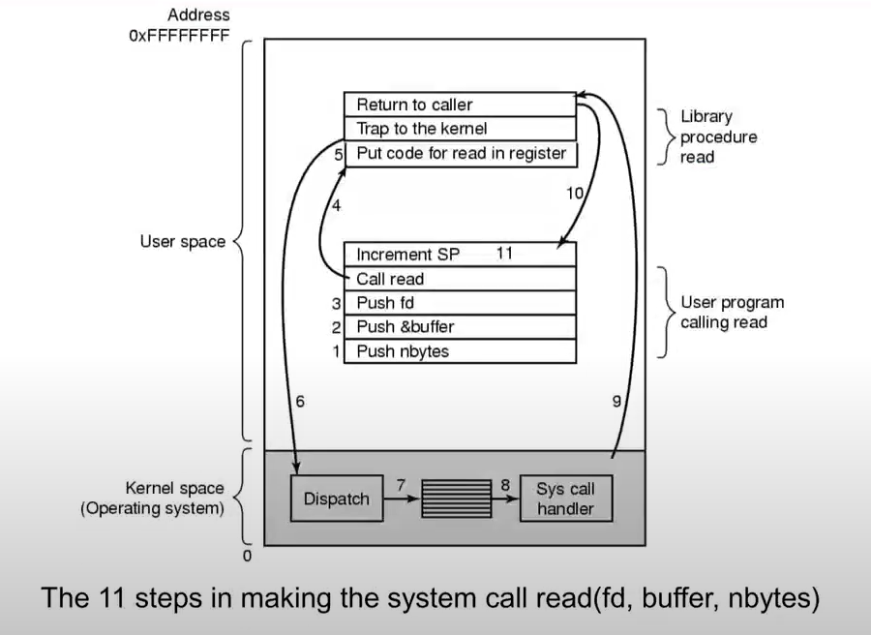

Interrupts happen from the hardware side most of the time. Disk controller can cause an interrupt saying that data is ready for example.

Another way other than interrupts to switch to the kernel is system calls.

System call read(fd, buffer, nbytes):

* fd: file descriptor
  + I opened the file, I am holding pointer to that file using fd
* nbytes: number of bytes to be read into the buffer

-----

1. Firstly push n bytes to the stack
2. pointer buffer itself is pushed to the stack
3. fd is pushed to the stack
4. I make a call. This is a library call. I am still in the user space. My program is making a function call. Function is in my user space.
5. All that function does is putting the code for system call read in a register (for example register number 1). That means I need to read some data. What are parameters for your read system call? They are available in the stack. Then I execute a special instruction which is system call. When I do the system call, I am in kernel space now.

6-7-8.

In kernel space, my CPU is in the kernel mode. It is running the OS code. OS code gets the code from register and it looks up the corresponding system call function. That system call function starts running. It reads data from the user space. It sets up the DMA device or however it is doing the I/O. When data is ready I can go back or after this point, if I set up the DMA device, I will wait for data to be ready. I can switch to some other process.

1. Go to library function.
2. Library function returns back to the original program.

System call is what happens when you write syscall in MIPS assembly.

Some OS says that I don’t need timer interrupt because I know that when the processes run, they will soon need help from the OS. They will ask to OS to do some stuff. When they ask it, I can do my process switching during that time.

**BUSES**

Additional buses were added, both for faster I/O devices and for CPU-to-memory traffic

The main bus is the PCIe (Peripheral Component Interconnect Express) bus

PCIe is both fast and can send data in parallel

Direct Media Interface (DMI), DDR3 buses

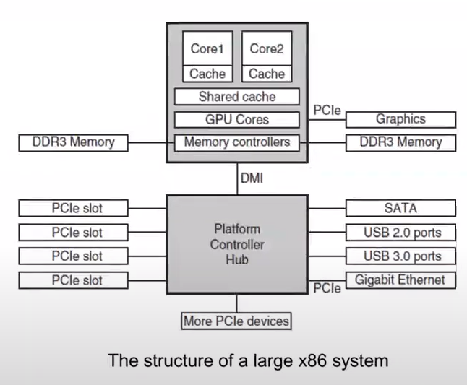

The USB (Universal Serial Bus) was invented to attach all the slow I/O devices, such as the keyboard and mouse, to the computer

USB 1.0 – 12 Mbps, USB 2.0 – 480 Mbps, USB 3.0 – 6 Gbps

All USB devices are hot plugable, no reboot required

* Before that, when you attach a new device, you had to reboot your computer

The SCSI (Small Computer System Interface) bus is a high-performance bus intended for fast disks, scanners (640 MB/s). SCSI is not fast nowadays but they are available for backward compatibility.

Booting the Computer

When the computer is booted, the BIOS (Basic Input Output System – very primitive small OS – you cannot run your program on BIOS) is started

* BIOS usually lives on ROM
* Task of it is boot your computer
  + It knows the computer, it gets the parameters, it sets up the OS to be loaded

It first checks to see how much RAM is installed and whether the keyboard and other basic devices are installed

Scan PCIe and PCI buses to see all devices

* Sees which ones are the mass storage devices, disks or the SSD devices
* Once it finds it, it loads the first sector from them

Tries to find boot device and boot

The first sector from the boot device (OS) is read into memory and executed

New version is UEFI: secure, faster, support more hardware

* Task is same: boot the computer, load the OS

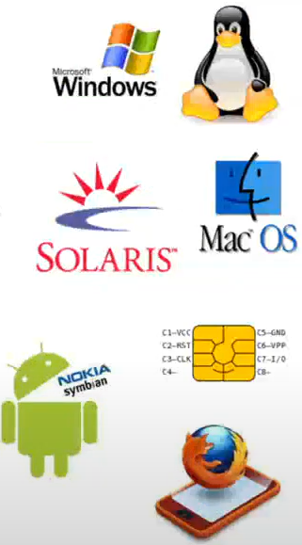**THE OPERATING SYSTEM ZOO**

Mainframe operating systems

Server operating systems

Multiprocessor operating systems

Personal computer operating systems

Handheld operating systems

Embedded operating systems

Sensor node operating systems

Real-time operating systems

Smart card operating systems

Same OS can behave like a server OS, multiprocessor OS, personal OS, etc.

Mainframe OS

try to achieve optimization of resource time

those room-sized computers still found in major corporate data centers

A mainframe with 1000 disks and millions of gigabytes of data is not unusual

batch, transaction processing, and timesharing

A batch system is one that processes routine jobs without any interactive user present

* I start calculating all the taxes for all country until I am done, I don’t need any user interaction
* It’s gonna take maybe 1 or 2 days to complete all the tasks but it is a large task that doesn’t need any user interaction

Transaction-processing systems (can be thought as small batch systems) handle large numbers of small requests: check processing or airline reservations

* Very large number of tasks, as a THY, you have to process thousands of reservations, cancellations, ticket sales, modifications, etc.

Many users are sharing the same CPU

* Usually it used to be at the universities, many people are using the same computer using time sharing

IBM OS/390 example system, Linux and Unix variants are becoming popular

Server OS

Either very large personal computers, workstations, or even mainframes

serve multiple users at once over a network and allow the users to share hardware and software resources

Servers can provide print service, file service, or Web services

* I have, lets say, 10-15 printers connected to my server and thousands of people are using the same print service
* I have thousands of disks connected to my system and I am providing file service to millions of people
* GTU web server runs somewhere but it gives service to thousands of users from all over the world

Typical server operating systems are Solaris, FreeBSD, Linux and Windows Server 201x.

* Red ones are Unix variations

Multiprocessor OS

Conventional desktop and notebook operating systems are starting to deal with multiprocessors and the number of cores is likely to grow over time

The hard part will be having applications make use of all this computing power

Many popular operating systems, including Windows and Linux, run on multiprocessors

Personal Computer OS

Linux, FreeBSD, Windows 8, Windows 10, and Apple’s OS X

Handheld Computer OS

Smartphones and tablets are the best-known examples

As we have already seen, this market is currently dominated by Google’s Android and Apple’s iOS, but they have many competitors

Interactivity, security, ...

Embedded OS

Embedded systems run on the computers that control devices that are not generally thought of as computers and which do not accept user-installed software

Embedded computers are designed for very specific purposes

TVs, microwaves, etc.

No need for protection

* Protection is keeping the data separate for different processes
* If I have a multiprogramming computer, keep the data and instruction separate for each process so that the processes cant see others’ data
* Embedded systems has specific tasks. What happens if one of the processes erases the other’s data either intentionally or by accident?
  + On an embedded system, you are not allowed to run your own software. You cannot download your software to microwave. If there are no user programs, all the user programs are written by the manufacturer of the microwave, they have to make sure that there are no protection problems

Embedded Linux, QNX and VxWorks are popular in this domain

Sensor Node OS

smaller and more primitive than embedded OS

Each sensor node is a real computer, with a CPU, RAM, ROM, and one or more environmental sensors

* used much in wild
* they run for even a year without intervention so they shouldn’t use much power

It runs a small, but real OS, usually one that is event driven (whenever an event occurs they wake up, handle the event, communicate with other computers around, then they go to sleep), responding to external events or making measurements periodically based on an internal clock

TinyOS is a well-known OS for a sensor node

Smart Card OS

The smallest OS run on smart cards, which are credit-card-sized devices containing a CPU chip

* There is a computer (smallest computer) on your credit card. That computer is booted whenever you insert your card to a card reader and whatever transaction you are doing is handled and computer is shut down.
* If there is a small computer, there will be a small OS on your credit card which is smart card OS.

They have very severe processing power and memory constraints

* No protection, no multiprogramming, no protected mode, no user, no interaction, etc.
* It does simple thing only

The ROM on the smart card holds an interpreter for the Java Virtual Machine (JVM).

* JVM is used and Java programs are run on top of this smart card OS

Java applets (small programs) are downloaded to the card and are interpreted by the JVM interpreter.

You cannot expect DMA controller, interrupt controller, etc. from this smallest OS

They are as primitive as computer of 1940s or first personal computer in 1970s

**OPERATING SYSTEM CONCEPTS**

Processes (About CPU)

Address spaces (About memory)

Files (About I/O and file system)

Input/Output (About I/O and file system)

Protection

The shell

Ontogeny recapitulates phylogeny

* Large memories
* Protection hardware
* Disks
* Virtual memory

Processes and Address Spaces

process is basically a program in execution

address space, a list of memory locations from 0 to some maximum

process table, an array of structures, one for each process currently in existence

* Registers, open files, other data

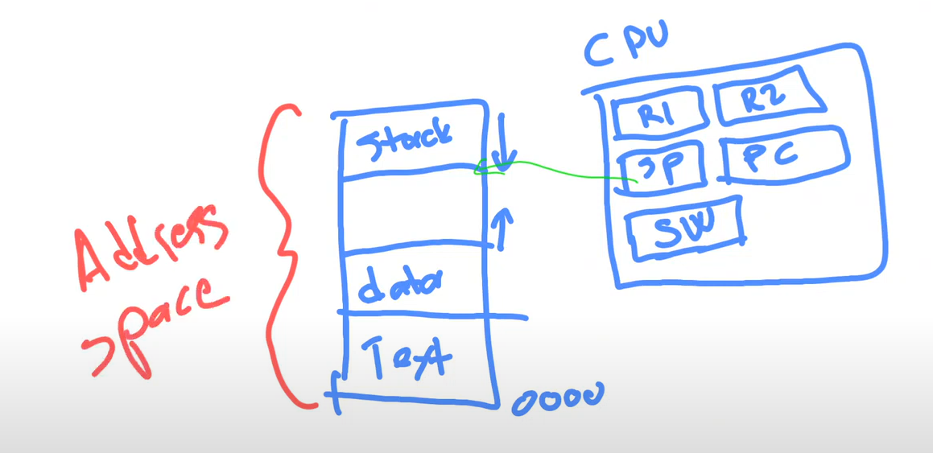

SP: stack pointer register

PC: program counter register

SW: status word register

Most of the time address space is logical address space means that each process has its own address space. It is not physical. Program thinks that it is physical. It shares physical locations with some other processes in a smart way.

If we have only this, not process table etc., than this is for one process only. It is like mainframe computers of 1950s and personal computers of 1980s. There is a single process and no OS.

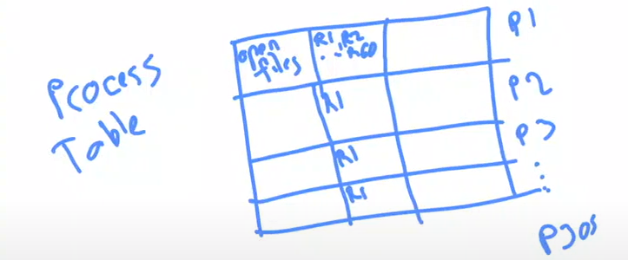

I have process table stored in memory. Since OS is a process too, it has its address space too. 305 is example. R1, R2… are registers kept in the process table in memory. Each process has their own R1, etc. When process is blocked, then I keep register data in CPU in my process table.

Context switch means that saving all your data in corresponding location (P1 row or P2 row etc.). Then if it is your turn, load your data in your process table to CPU.

I have also time keeping data in process table.

How much percent of CPU I am using and how much I had used are kept on my process table as you can see at the task manager. This information is very useful when OS does scheduling. If one of the processes is not using the CPU for a long time then I switch to that one.

You can change priority of the process at task manager. If you make priority very high, during scheduling, that process will get the priority.

CPU percentages for processes at task manager means this: for full 1 second of the CPU, x% (x is what is the percentage for that process) of the CPU time is spent for that process. If all CPU time is 20%, 80% of the time CPU is idle.

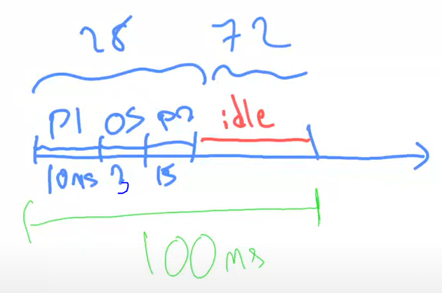

Why CPU is idle, because process 1 and 2 are blocked. Maybe they are waiting for some disk data, some mouse input, etc.

72% of the time CPU is idle, 28% of the time CPU is busy. That is the CPU usage.

What happens if CPU is 100%? Interactivity gets slow. I am not getting response right away now. I have to wait a little more because I have to share my CPU with many other processes.

If OS is good and optimized, even at the 100% CPU utilization computer may not appear to be slowing because I have enough CPU time, I can respond to it.

If I keep using too much memory, then things get very bad because I don’t have enough space to do context switching.

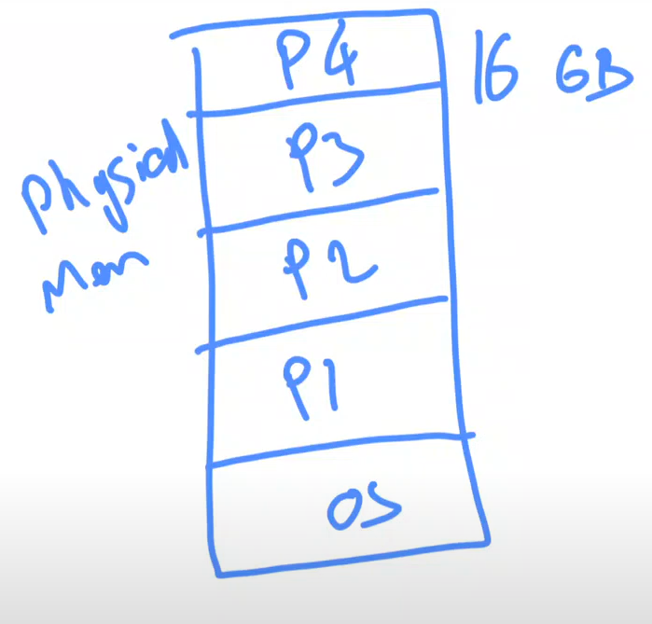Lets say I have to keep 5 processes in this memory so that I can switch between them, I don’t have enough space. I am gonna take P2, for example, write it to disk then I need to load P5 to that location in memory.

Disk access is more expensive than context switching so main problem is because of the memory utilization, not because of CPU utilization.

This is called trashing.

CPU is actually idle.

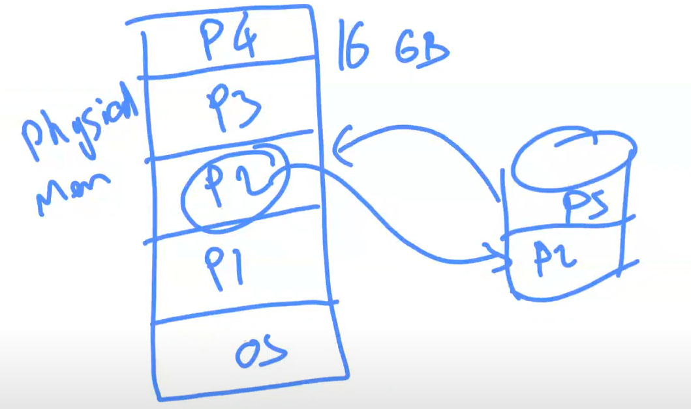

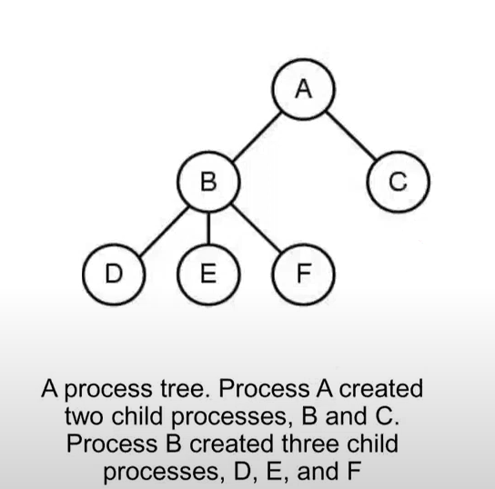Related processes that are cooperating to get some job done often need to communicate with one another and synchronize their activities.

When computer starts, there is only 1 process (we will see this process). This process constructs new processes and tells to OS that I have a new process now. Those processes become child processes of A. B can say that I am gonna make 3 more processes.

This is process tree, hierarchy.

Usually processes help each other. A asks B and C to do sth. B asks D and E and F to do sth. Whenever they are done, they communicate back the data to parent process. This communication is called interprocess communication.

It is very simple to communicate between 2 processes. Only you share the data in the memory.

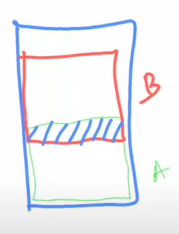As you see, I am sharing some space between processes. If I write some data to this space, A and B can communicate between each other.

There are many problems that can arise from this kind of data sharing. Most of them are called race issues. I have to do this communication in a synchronized way.

Main problem happens this way: While A is writing sth to this space, if B is reading it at the same time, there will be some chaos that needs to be solved. If both of them are writing to same area, it is more problematic.

In Windows, from the kernel of the system, we don’t have parent child relationship.

In Unix (and Linux of course), we have parent child relationship.

If you kill process A in Unix, all of the child processes that belong to process A will die too.

Files

most PC operating systems have the concept of a directory as a way of grouping files together

Path name, root directory, working directory, file descriptor (an int)…

I need to keep my access data. I cant keep everything on my memory because memory is too small. Also memory is volatile. When the power goes off, memory goes off too. I lose all the data in memory.

As a permanent storage, I need my secondary storage. That’s where the concept of file comes in.

File is just a data structure that keeps related data on our secondary storage.

If you keep related files together, that becomes directory (folder).

In order to find the files in secondary storage unit, I need to know its address. Address is known by the path name.

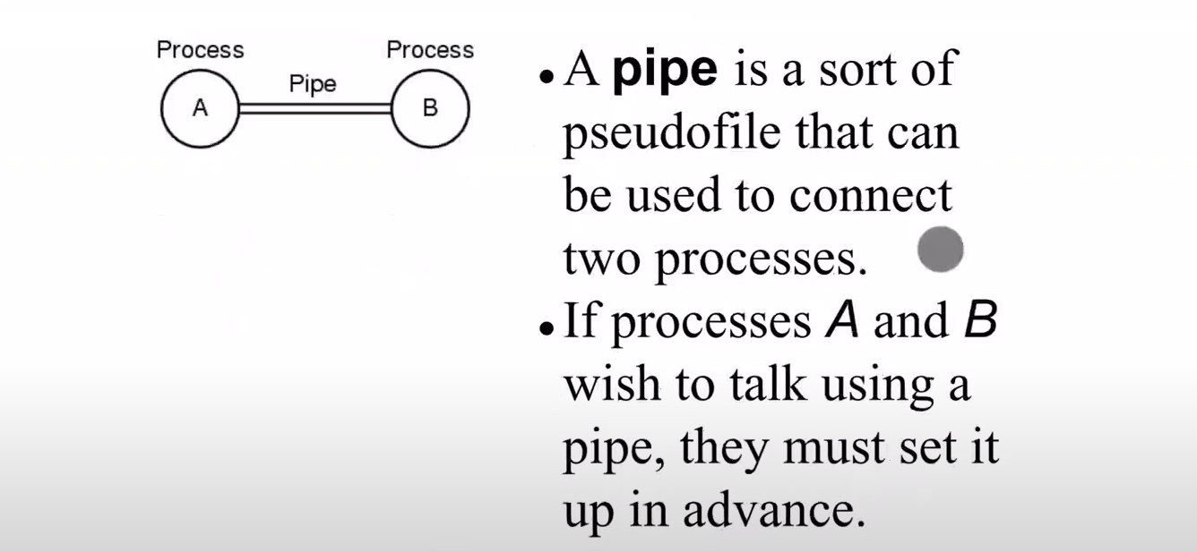

*NOT SO IMPORTANT*

Ontogeny Recapitulates Phylogeny

development of an embryo (ontogeny) repeats (i.e., recapitulates) the evolution of the species (phylogeny).

Each new “species” of computer

* Goes through same development as “ancestors”
  + Memory: 1964 main frames had 128 KB memory: assembly was used
    - Since I don’t have much space, I can’t keep more than 1 process in my memory so there was no OS
    - I cant keep compiler on my memory, that’s too expensive. So I write all of my programs in assembly
    - Later when they invented smaller and more efficient transistors, PCs became feasible.
  + 1980: PCs had 64 KB memory: assembly was used
    - In 20 years, we had to go back and write our programs in assembly again
  + Smart cards (has own CPU, memory and OS) are doing the same too
    - Nowadays or maybe 10 years ago
    - We had to use assembly to make it more efficient. CPU is weak and there are memory limitations.
  + ---------------------------------------------------------------------------------------------------------------------
  + Protection (Each process has its own address space and CPU. Even if I want to intentionally modify other process’s data, I cant do that because there is the protection provided by the hardware) hardware: 1960s no protection
  + 1980s 8086 (CPU) had no protection
    - That’s why we didn’t have many OS that could run more than 1 process on this processor
  + Many embedded systems (specialized computers) have no protection
    - Same things are happening today.

Consequence of impermanence

* Text often looks at “obsolete” concepts
* Changes in technology may bring them back
  + Whenever a new smaller type of computer and OS is invented, we have to solve the same problem over and over again

Happens with large memory, protection hardware, disks, virtual memory

ALTAIR 8800 didn’t have any OS, just had basic interpreter. You program your computer using machine code.

Bootstrap loader is maybe 20 bytes of program that says that read sth from I/O port “this number” and do this until you hit the end of the tape. It is a simple loop.

<https://www.youtube.com/watch?v=qv5b1Xowxdk>

In video, guy is loading simple bootstrap loader at first. That simple one is gonna read more sophisticated loader from the tape. That program is gonna load the rest of the tape.

When switch from bootloader to more sophisticated bootloader that had read from the teletype happens, lights of the ALTAIR has changed (4:35).

All of the data that is read from teletype is about 4 KB.

Teletype device is used for input and output device. There is no terminal.

System Calls



read 🡪 you open a file, if opening is successful, you start reading from this file descriptor inside this buffer for nbytes.

For different type of CPU, there are different mechanisms of system calls.

When you make a system call, you need to know that you are know in the kernel space. CPU is running instructions in privileged mode.

Inside the kernel mode only OS code runs.

When instruction issued, OS takes the control and it DISPATCHES.

Dispatching means that finding what the end user or the user program or the application program needs. You say that inside the special register, I will find the code but it looks like it is asking for read operation and I am gonna handle read operation this way.

All you can do with a system call, you cannot execute your own code, but you will say that run the system call number 7, 10, 11, etc.

System Calls for Process Management

POSIX (Portable Operating System Interface – system call interface) has about 100 procedure calls.

* Procedure call is almost same as system call but a bit different.
* Each call might be converted to system call, or it might be handled in the user space.
  + If it is not possible to handle in user space, then context switch happens.

POSIX procedure calls onto system calls is not one-to-one.

* POSIX says that I am gonna define procedure calls but not all procedure call we translate to system call because some of them can be handled in the user space. Some of them needs to be system calls.
* For now, conceptually, we think procuedure calls as system calls.

The POSIX standard specifies a number of procedures that a conformant system must supply, but it does not specify whether they are system calls, library calls, or sth else.

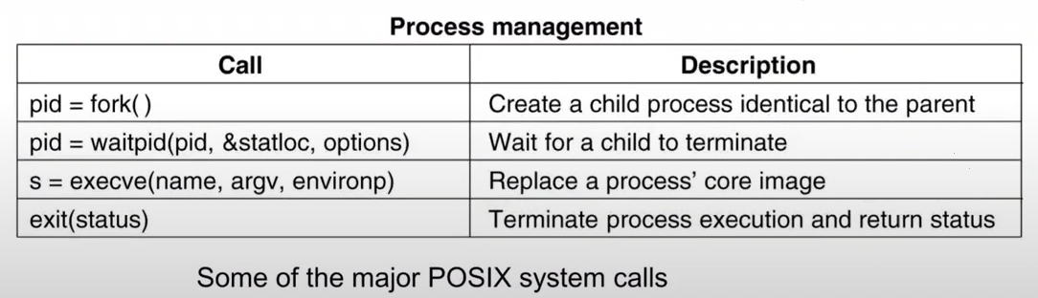

One procedure call group is process management. These procedure calls are related to making a new process, killing a process or getting some information from a process, changing the core of the process, etc.

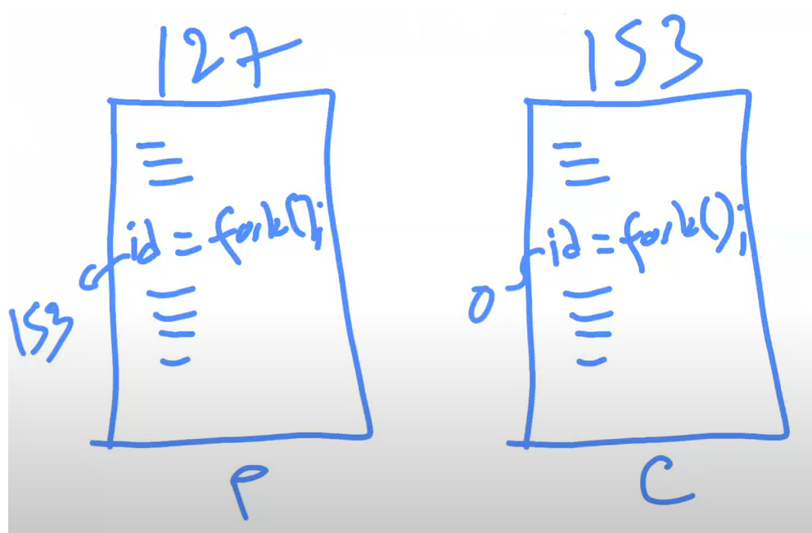

Process 127 is running some instructions and it said fork() at some place.

This fork() library function will in turn make a system call.

fork makes a copy of this exact 127 process but it is a new process. Lets call it process with ID 153.

Now I have 2 proceses that looks like running at the same time in my memory.

What is the point of running the same thing twice? They are gonna do exactly the same thing, their data is same, everything is same.

* fork returns a value.
* For process 127, returned id is id of the child process which is 153.
* For process 153 (child process), returned id is 0.
* This is the only difference.
* Parent and child can distinguish themselves.

These two processes are independent from each other. They can continue running until they end. It doesn’t mean whenever I make a new process 153, it will run and it will complete and come back where fork is called.

As soon as you do fork, both 127 and 153 are running now at the same time. They are doing exactly the same thing. 153 began to run same code as 127. To do sth useful, I need to make a new change on 153. That’s why we need procedure calls execve.

We need to change our process’ core image. We are gonna say that execute program named “name” using “argv” and “environp” parameters in process. Change my core image, change everything inside my process with “name” program on the disk and start running it.

If you execute exit(), you will terminate your program.

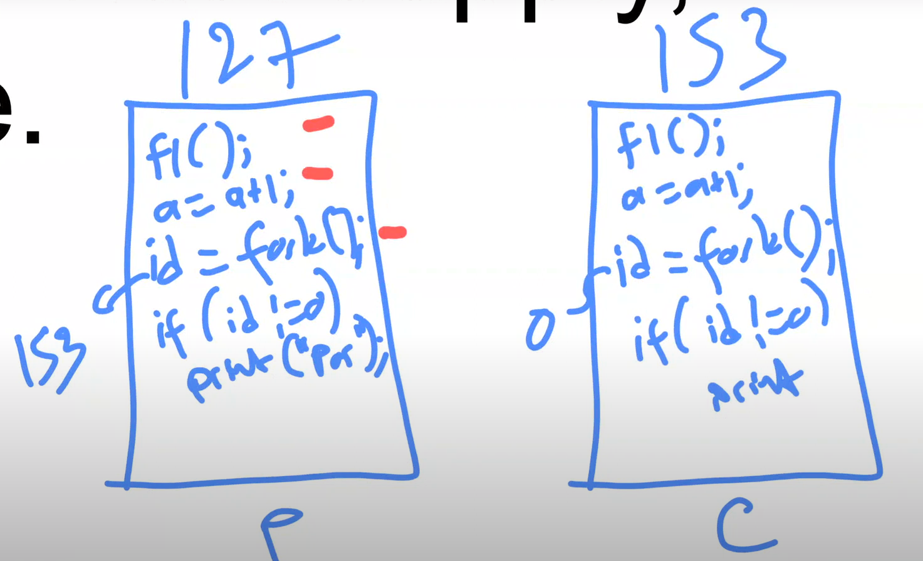



As soon as I executed “id = fork();” line at 127, 153 will be constructed. Both of them will execute same line (“id = fork();”). There will not be infinitely many forks. 127 will print parent but 153 will not because id is 0.

Then both of them continue to run same things below.

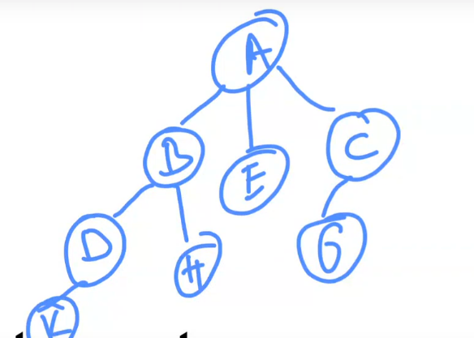

If you do “while(true) fork();” 🡪 this will create infinitely many processes. After a while, your OS will either crash or it will stop you saying that there is no enough memory to make so many processes.

As soon as I hit fork() as process A, there will be another process B. Both A and B are running the same code. A will fork another one C, B will fork another one D. Now they are all running the same code. A will fork E, C will fork G, B will fork H, and D will fork K.

I am exponentially making new processes (1+1+2+4+8…). If you keep running this, you will fill up your memory with lots of processes. That’s not gonna look very nice.

waitpid (wait process id) is some kind of interprocess communication mechanism. You will say that I am gonna wait until a child terminates. You are now waiting until the child terminates. When child terminates there is an exit status, you will get that from status location. That’s what child returns you.

*Lets write very simple LINUX shell:*

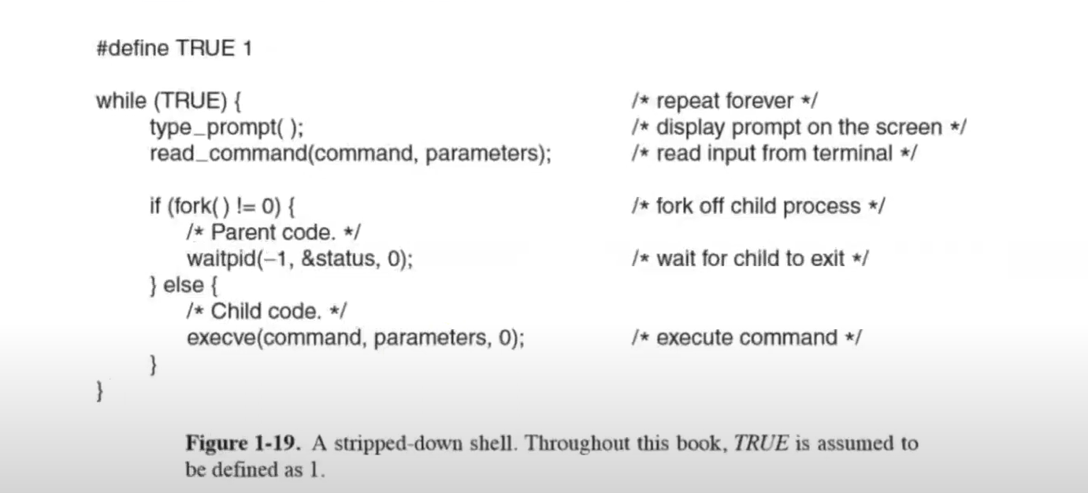



Shell is an infinite loop.

prompt on cmd 🡪 C:\Users\Mert>

Shell (cmd in Windows) is waiting for me to type sth. I can give commands and they are executed.

c:\Windows\explorer.exe ---> you can run explorer with this command. Now both shell program and explorer are running at the same time.

This is not Unix, this is not child process of other one. It is not blocked. In Unix, when I do the fork, things are different.

After the first fork, I have 2 shells running because I created the same program. This first fork will return a non-zero value for the parent but 0 value for the child.

For the parent:

* I am gonna wait until child terminates so this current parent process is blocked at this position (waitpid line).
* When you type a complex command, it takes a few seconds to come back for shell in Linux. While I am executing the command, it is blocking my input because I am waiting for that.

For the child:

* This execve part replaces all code and data and whole process whatever it is specified with “command”. For example when I give command “cd”.cd is a program and it runs and it does some stuff.
* Whatever command you gave, it is loaded and it changes the whole core of the child process

When execve finishes, core of the program changes and nothing remains out of this program. Now I have new program running. When it terminates, this child terminates. Then waiting parent will be free. Loop will continue again.

What happens if we take the red part out and only do execve?

* It will not be good.
* execve changes the core of the current process.
* So OS will change my process’ core with the new command loaded from disk. When I execute that command, this current process will be over. While loop is all gone.
* It would just executes 1 command and that’s it.

*ps (process status) command in Linux 🡪 for viewing information related with the processes on a system. Outputs are inside process table.*

System Calls for File Management

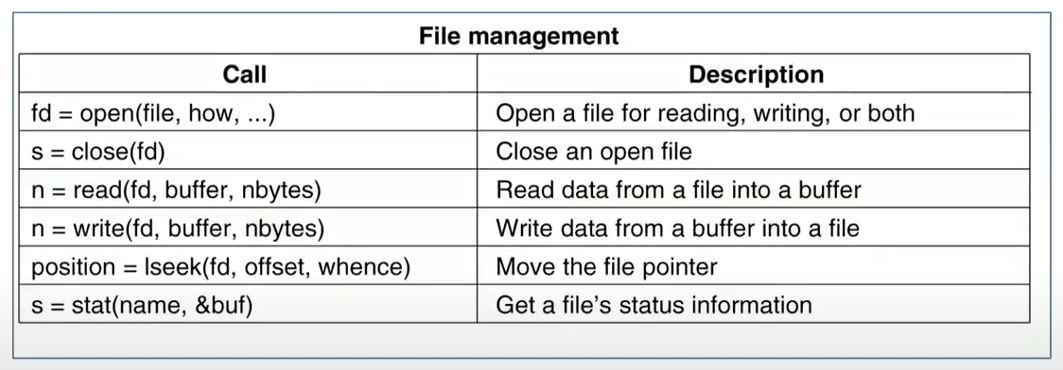

*Some of the major POSIX system calls*

Those functions are translated to system calls because as a regular user program running in the user mode, you don’t have access to files directly. You have to ask to OS to open the file or read the file from the disk.

fd is file descriptor. It is just basic integer, index to open file’s data structure in your process table. OS keeps this table.

Every process has its own open files. No process can access to other process’ open file list. OS keeps them in the process table.

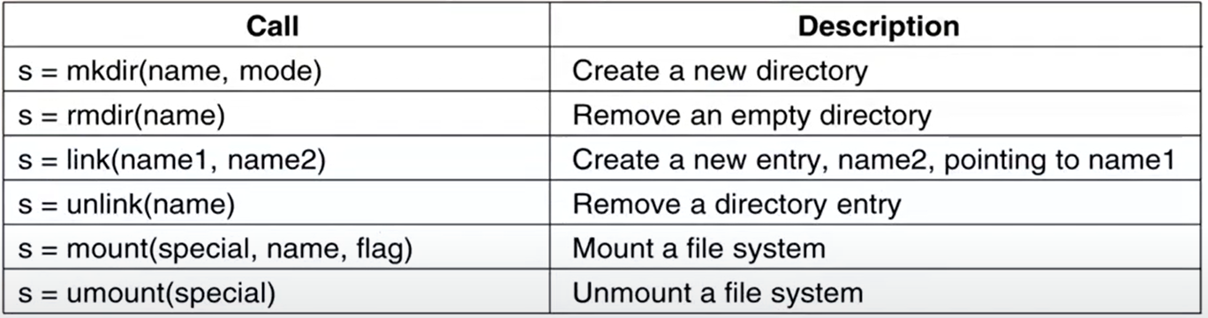

link(name1, name2)

* name1 already exists on my disk in my file system
* name2 is just a pointer to name1. It is a copy.

Miscellaneous System Calls

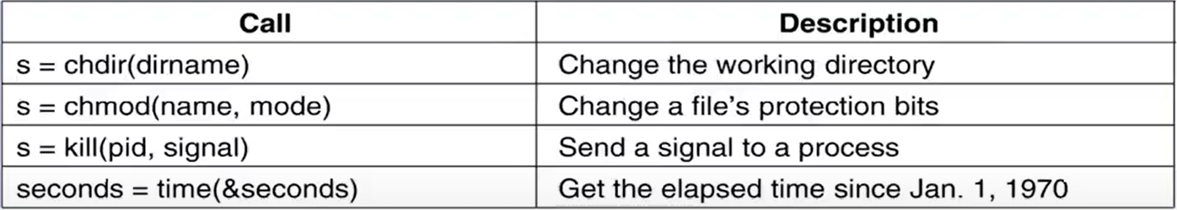

*Some of the major POSIX system calls*

Most common signal is signal number 9 which is killing the process itself. So you are sending a kill signal to a process. Process takes that signal and handles it.

How does a process handle a signal?

* In UNIX, all the processes are formed in a way that they handle these signals.
* Most of the time they ignore most of the signals but they have to handle it.
* Their default behaviour to handle a kill signal is to die.
* It is possible to prevent this behaviour. When you get a kill signal, you may resist dying, you may do sth else.

kill -l

* kill is the UNIX command for sending a signal to a process from a command line

All the processes can handle their own signals.

We don’t have signaling in Windows. We have other types of mechanicsms of communicating with the processes.

chmod(“file”, 0644)

Changing directories is only done for the current process.

When you do “whereis ls”, then you can find location of ls.

When you do “whereis cd”, then you cant find anything. Remember structure of shell we wrote a few pages before. It cant handle cd. Also LINUX shell cant handle cd neither. Why don’t I have a program for cd on my file system?

* There is a system call cd, we know that.
* cd doesn’t have standalone program.
* If I execute cd in my shell program for example, a process runs, it changes its own working directory and terminates. It doesn’t change my current process’ working directory.
* It doesn’t make any sense to run a separate cd command. It would change that command’s working directory.
* Same is with exit command. That would terminate that another program, not my program.
* They need to be build in cell.

time(&seconds)

* I am gonna give you a pointer to an integer and give me the number of seconds elapsed since Jan. 1, 1970
* Returns the current time in seconds, with 0 corresponding to Jan. 1, 1970 at midnight.
* On computers using 32-bit words, the max value time can return is 232-1 seconds. This value corresponds to a little over 136 years

Memory Layout

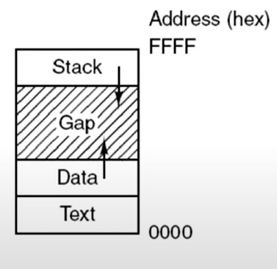Processes in UNIX have their memory divided up into 3 segments:

1. the text segment (i.e., the program code)
2. the data segment (i.e., the variables
3. stack segment

This actually depends on processor structure, machine structure, etc.

In physical memory, things are very different. It doesn’t make sense to keep an empty space in your memory, because you will need it later. We have so sophisticated memory handling hardware support and OS supports that.

In physical memory, we don’t keep any gaps. We also don’t use all these data contiguously. It is all distributed all over the memory. You will never know which part of your data is on the disk and which part of the data is in main memory (core memory) as a process.

Sometimes we call main memory as core memory because in the early days memory is built by hand.

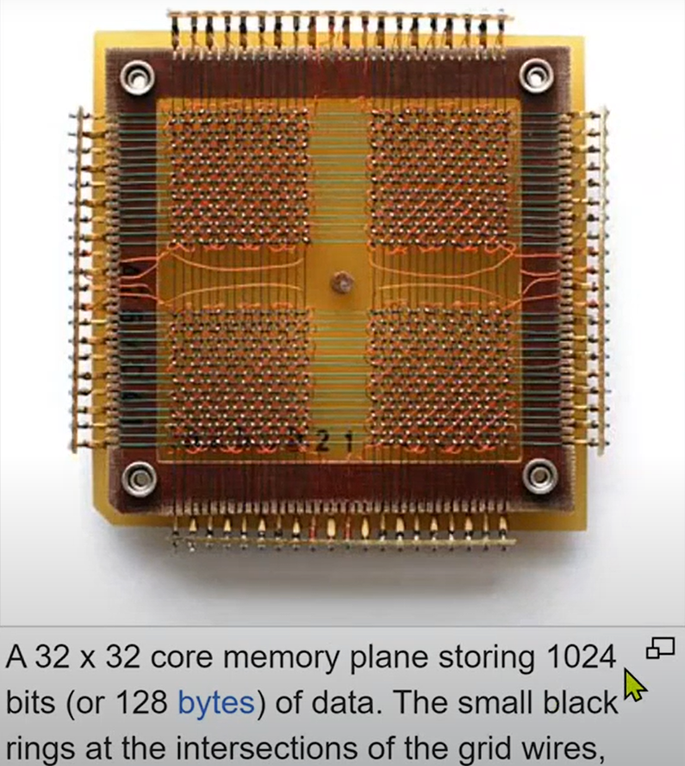

These are called cores. Physically you see each bit. These are magnetic representation of the bits.

Apollo computer used core memory because you try to use proven technologies, not newest ones for space program.

Sometimes they didn’t use permanent magnets, they used wirings for those.

Linking

A directory is simply a file containing a set of (i-number, ASCII name) pairs.

Every file in UNIX has a **unique** number, its i-number, that identifies it.

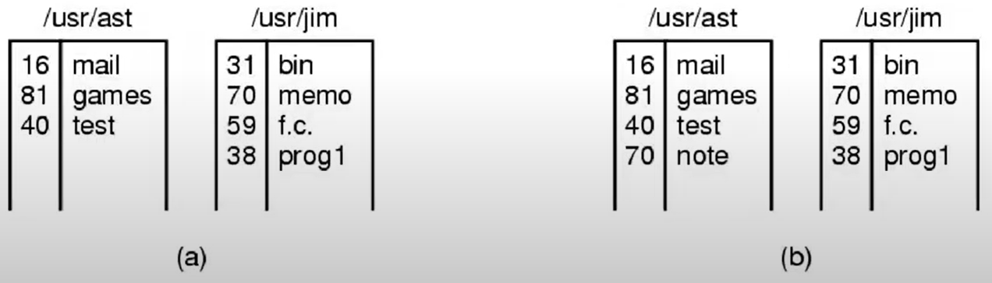

When I do this in /usr/ast directory in situation a,

* link(/usr/jim/memo, note)

b happens. i-numbers are common. If you modify one of them, other file will be modified.

Mounting

If you like to use another disk drive, then you mount that disk drive to some place in the directory structure.

mount(“/dev/sdb0”, “/mnt”, 0);

* /dev/sdb0 is my device driver for a disk
* mount this disk at /mnt position
* 0 is flag

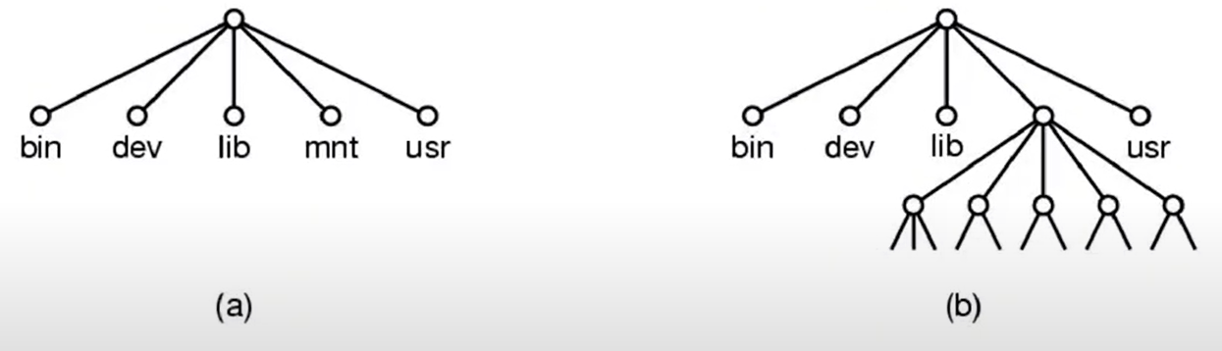

a) file system before the mount

b) file system after the mount

There is always one root position in LINUX system. All the disks, all the secondary storage hierarchies have to be mounted at some position.

In Windows, I have different letters for logical or physical drives. Also D and E (for example) may be parts of the same physical disk drive, but I may see them as different secondary storage units.

Windows Win32 API (Application Programming Interface)

By decoupling the API interface from the actual system calls, Microsoft retains the ability to change the actual system calls in time (even from release to release) without invalidating existing programs.

The number of Win32 API calls is extremely large, numbering in the thousands.

Windows says these are my procedure calls.

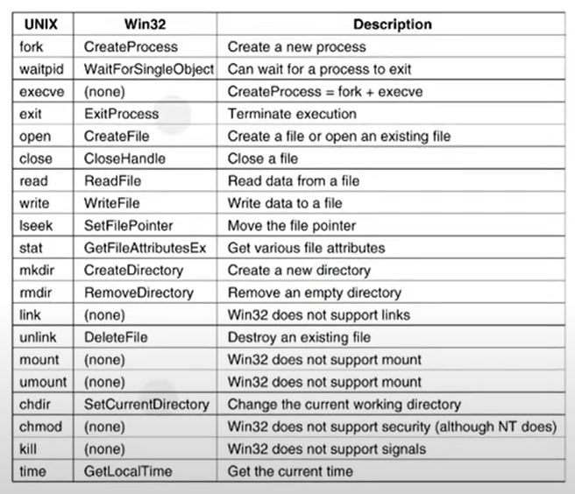



*The Win32 API calls*

With CreateProcess, you fork and you execute a command. That’s the create process. There is no copying of the parent process.

You might think this is more efficient but in fact, fork is very efficient. When I say make a fork, it doesn’t copy anything because it is same as parent. Code is not copied, code is shared. Since data is same at the beginning (data is shared too, not copied), if you start modifying your data then in that case it will be copied. It takes advantage of virtual memory a lot.

Windows, from the kernel, doesn’t support the modes of a file. Except NT and some newer versions.

Mode of a file has 3 things:

* Read 🡪 Can I read this file?
* Write 🡪 Can I write to this file?
* Execute 🡪 Can I execute this file?

It is RWX RWX RWX. I have 3 of them. For user, for group, for everybody else in order.

Each one is bit 🡪 111 111 111

Octal 🡪 7 7 7

If I have 777 for a file, everybody can read, write, and execute that file.

POSIX has 100 procedure calls.

Win32 has more than 1000. Reason is:

* Inside Win32, you have GUI.
* Windows supports GUI from the kernel of the OS.
* UNIX doesn’t do that. UNIX says GUIs are not part of the OS. They run as separate process. They don’t run in kernel mode because they are very fragile. If sth goes wrong, they will take the whole OS with them.
* Windows says those are system calls. Making a new window, moving a window, etc. They can do whatever they want with the hardware since they are system calls. They are more efficient.

UNIX is designed after MULTICS. They tried to simplify MULTICS OS and address some of the problems of it.

Windows tried to keep backward compatibility with the previous versions of Windows when they introduce a newer versions of Windows. So sometimes you don’t understand whats going on.

Operating Systems Structure

By far the most common organization, in the monolithic approach (no plan, just write the OS) the entire OS (millions of lines of code) runs as a single program in kernel mode.

This makes OS very efficient, everybody can call everybody. There is no limitations.

Also this makes it difficult to upgrade this OS, keep it running, find the bugs, make it run more efficient, etc.

Being able to call any procedure you want is very efficient, but having thousands of procedures that can call each other without restriction may also lead to a system that is unwieldy and difficult to understand.

Also, a crash in any of these procedures will take down the entire OS.

Monolithic systems – basic structures:

* A main program that invokes the requested service procedure
* A set of service procedures that carry out the system calls
* A set of utility procedures that help the service procedures
* DLL’s are loadable extensions

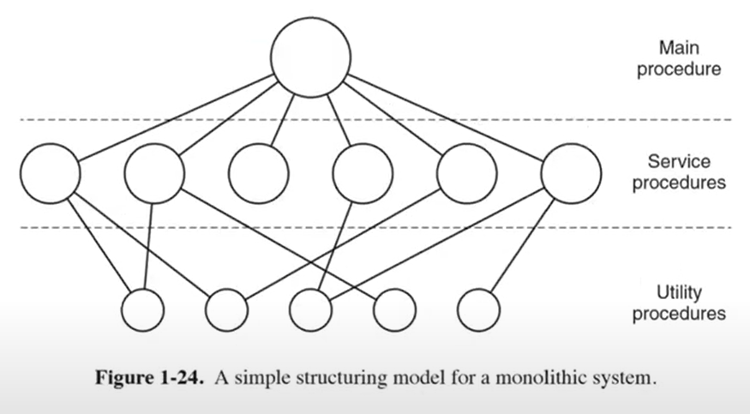

There is some structuring to it. The procedures are sharing some common software, packages. But again everybody can call everybody, there is no restriction.

Layered Systems

Some people don’t do it that way.

They say “We are gonna get help from the hardware and we will write our OS in layers.”

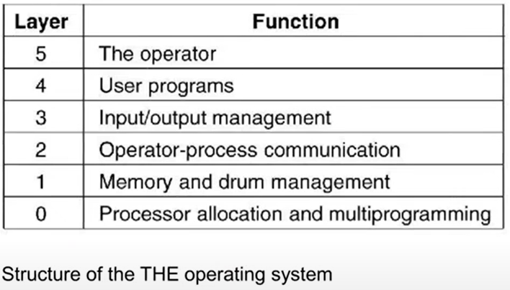

Hardware itself says that I have 6 different levels of hardware protection.

Layer #0 is most privileged.

Not all parts of your OS can do whatever they want. They have to be at the appropriate level.

Instead of layers, MULTICS was described as having a series of concentric rings, with the inner ones being more privileged than the outer ones.

In MULTICS, the ring mechanism was very much present at run time and enforced by the hardware.

Microkernels

A monolithic OS of 5 million lines of code is likely to contain between 10000 and 50000 kernel **bugs**.

The MINIX 3 microkernel is only about 12000 lines of C and some 1400 lines of assembler code.

MINIX is POSIX compatible microkernel OS. It just handles interrupts, processes, scheduling and interprocess communication. For the rest (networking, file system, etc.), they will run in user mode.

You have to handle interrupts in the kernel mode bc when interrupt happens, you have to look up the interrupt table and find the appropriate function etc.

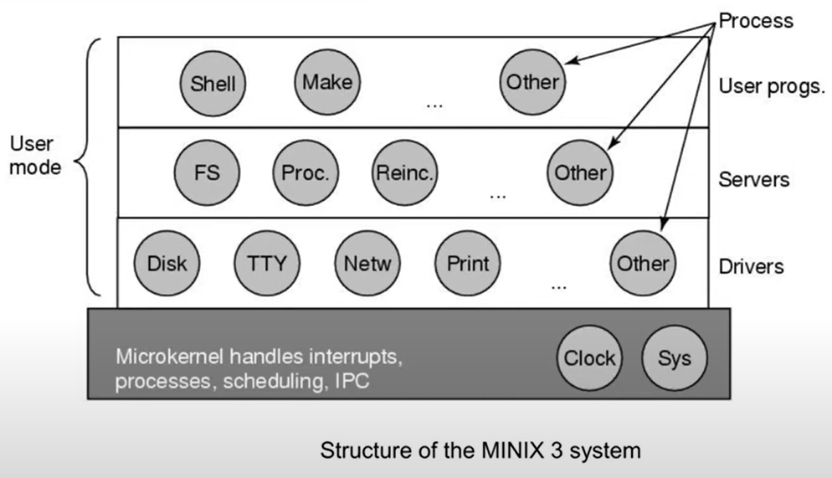

Kernel is critical, lets keep it very small. Only a few thousands lines of code.

You cant to input/output, file systems, etc. with that small code.

Microkernel OS says that “I am not gonna keep the drivers or servers in my kernel. I will keep them as separate user mode processes. Whenever they need to do sth privileged, they will ask to kernel to do it for that process.”.

How could you access a disk controller’s memory if you are the disk driver, obviously you cant. You are gonna ask to kernel to access it for you. Everytime you made such a request, there will be a context switch, system call. That’s the downside. They need to make lots of system calls.

Windows is opposite, they put everything inside the kernel including the GUI.

Things that happen very often is in kernel space

Client-Server Model

A slight variation of the microkernel idea is to distinguish two classes of processes, the servers, each of which provides some service, and the clients, which use these services.

Communication between clients and servers is often by message passing.

A generalization of this idea is to have the clients and servers run on different computers, connected by a local or wide-area network.

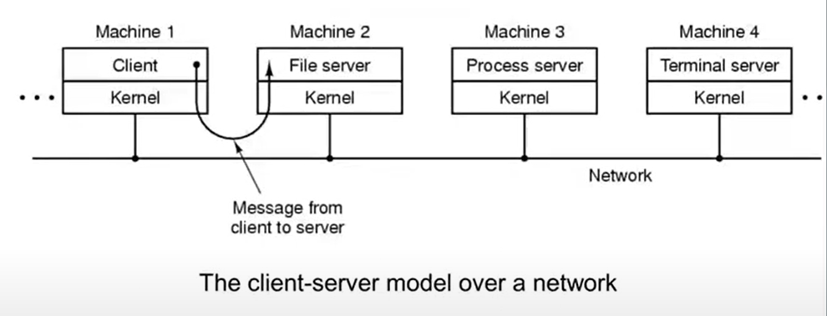

As a client, if I need to do sth about the processes, I asked to kernel. Kernel either does it or it asks server process to do that.

Clients and servers don’t have to be on the same machine. If they are on same computer, it becomes sth like microkernel structure. They could be on different computers and those computers are connected by the network.

Kernel is very small. All the clients and servers run in user mode.

For example, if client wants sth like “I want to open a file and I need to fork a new process”, this is asked to kernel and kernel gets it done by asking these file servers or process server and do the things.

Sometimes server could be a client too.

Communication between clients and servers often done by message passing, it is a way of interprocess communication.

Virtual Machines

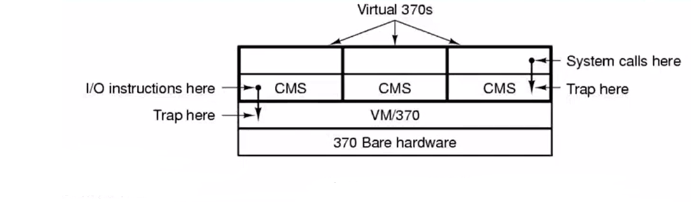The heart of the system, known as the virtual machine monitor, runs on the bare hardware and does the multiprogramming, providing not one, but several virtual machines to the next layer up, because each virtual machine is identical to the true hardware, each one can run any OS that will run directly on the bare hardware.

*The structure of VM/370 with CMS*

CMS is OS that runs in user mode, not in kernel mode. If CMS tries to do sth privileged, it is trapped to real OS (VM/370) which runs in kernel mode.

Each CMS does process scheduling between its own processes. VM/370 does the OS scheduling between 3 CMS.

VM/370 shows itself as bare 370 hardware.

If hardware powerful enough, CMS OSs never notice that they are running on a virtual machine.

For example, whenever one of the CMSs needs to do sth specialized such as accessing the MMU, it tries to access to hardware traps that access to this software level VM/370.

VM/370 is kind of a very simple OS. It only knows about the traps and hardware access and everything. It can do some memory management and it can do some process management.

Most of the complicated OS stuff is done at CMS.

What is the advantage of running the 3 copies of same OS (CMS) on the same hardware?

* If any crash happens in any one of them, other 2 will not get affected.
* CPU time is very important. If I realize I am wasting 60% of the CPU time of my computer, I would run 2 more CMS OS and rent them out to some other companies. They would never know that they are sharing my hardware with other people.

*Virtual Machines Rediscovered:*

* While IBM has had a virtual-machine product available for 4 decades, the idea of virtualization has largely been ignored in the PC world until recently.
* Intel processors did not support virtualization. If you are in user mode and try to do sth privileged, I will terminate the process or sth like that. One of the reason for late discover.
* Companies see virtualization as a way to run all services (mail, web, etc.) all on the same machine without having a crash of one server bring down the rest.
* When an OS running on a virtual machine (in user mode) executes a privileged instruction, such as modifying the PSW or doing I/O, it is essential that the hardware trap to the virtual machine monitor so the instruction can be emulated in software.
  + As a real OS running in kernel mode, I realized that somebody is trying to do sth privileged. If I recognize that process as a guest OS, then I will let it do or I am gonna do it myself. That process is gonna think that “I am accessing the hardware.”.

Nowadays, Windows OS comes with Linux kernel. There is a Linux kernel living somewhere on computer and it is running in the virtual mode as a separate OS.

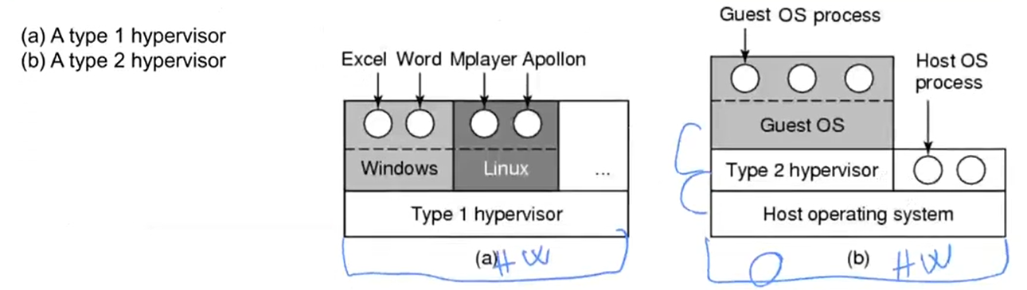

A type 2 hypervisor makes uses of a host OS and its file system to create processes, store files, and so on.

A type 1 hypervisor has no underlying support and must perform all these functions itself.

supervisor is boss, hypervisor is boss of boss.

The Java Virtual Machine

When Sun Microsystems invented the Java programming language, it also invented a virtual machine (i.e., a computer architecture) called the JVM (Java Virtual Machine). JVM provides a machine that looks like hardware for Java bytecode. It has its own garbage collector etc.

The Java compiler produces code for JVM, which then typically is executed by a software JVM interpreter.

The advantage of this approach is that the JVM code can be shipped over the Internet to any computer that has a JVM interpreter and run there.

Exokernels

Rather than cloning the actual machine (I am cloning 3 CMSs. Each CMS think they own the whole machine.), another strategy is partitioning it, in other words, giving each user a subset of the resources.

Thus one virtual machine might get disk blocks 0 to 1023, the next one might get blocks 1024 to 2047, and so on.

The advantage of the exokernel scheme is that it saves a layer of mapping.

In the other designs, each virtual machine thinks it has its own disk, with blocks running from 0 to some maximum, so the virtual machine monitor must maintain tables to remap disk addresses (and all other resources).

Lightweight virtual machine.

The World According to C

Operating systems are normally large C (or sometimes C++) programs consisting of many pieces written by many programmers.

In many places, you revert back to assembly programming.

The C language (int, pointers, malloc, free)

Header files

* #ifdef X86
* intel int ack();
* #endif

Large programming projects

The model of run time

The Model of Run Time

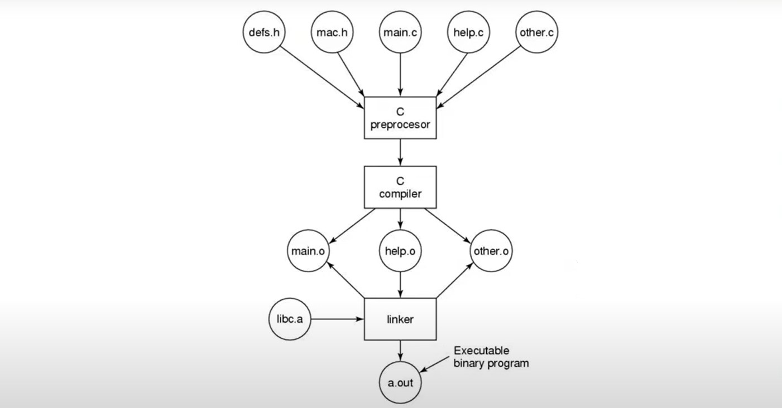

*The process of compiling C and header files to make an executable*

Sometimes linking is static, sometimes dynamic.

If linking is dynamic, there are dynamic link libraries (DLL). They are shared between the processes. So we like them, they make our programs smaller. You need to send your DLL to customer.

